     

COURSE NAME : DIGITAL MARKETING

GROUP NUMBER : 06

PROJECT TITLE : CREATE AN SPONSORED INSTAGRAM POST USING CANVA.

PROJECT SUBMITTED TO : ANNA UNIVERSITY / NAANMUDHALVAN

YEAR : 2023-2024

DEPARTMENT : HANDLOOM AND TEXTILE TECHNOLOGY

SEMESTER : 07

GROUP MEMBERS : ANAYAT HYDER SHEIKH

SAI VARAPRASAD AKULA

AMAR JYOTI DAS

ANUSHA A U

GUIDED BY : S. BABU PRIYA AP / MANAGEMENT

STUDIES

SPOC NAME : DR.C. PRABHAKARAN

SENIOR LECTURER IN TEXTILE

**INDEX**

1. ABSTRACT
2. INTRODUCTION
3. OBJECTIVE
4. STEPS TO FOLLOW
   1. Navigation
   2. Search “canva”
   3. Click “Instagram post”
   4. Search “Instagram post templates”
   5. Search and click online store.
   6. Choosing the design logo.
   7. Change background colour.
   8. Choosing background image.
   9. Click “colour and fonts”
   10. Change “style of text”
   11. Give your own text thoughts.
   12. Change the font and install pictures.
   13. Click “share”
   14. Click “download”
   15. Share it on instagram.
5. CONCLUSION

**ABSTRACT**

Creating an Instagram post using Canva is a user-friendly and creative process that leverages Canva's design tools and templates to create a visually appealing and functional templates. Canva, primarily known for its graphic design capabilities, now offers a feature called Canva posts, which simplifies post creation for users without extensive coding or design skills. Users can choose from a variety of professionally designed templates, customize them with their own content, images, and branding elements, and publish their post with ease. Canva posts provides a convenient drag-and-drop interface, making it accessible to beginners and small businesses looking to establish an online presence quickly and affordably. Creating a insta post using Canva is an innovative and accessible approach to web design that empowers individuals and businesses to craft visually appealing and functional websites without the need for extensive coding expertise. Canva, a user-friendly graphic design platform, offers a rich array of tools and features that simplify the post creation process.The journey begins with choosing a post template from Canva's extensive library, providing a strong foundation for customization. This template can be tailored to suit the unique branding and content requirements of the user. Layouts, color schemes, typography, and graphics can be easily adjusted to achieve a cohesive and appealing design.One of Canva's strengths is its support for multimedia integration. Users can effortlessly incorporate images, videos, icons, and other multimedia elements, enhancing the overall aesthetics and engaging users effectively. Canva also supports responsive design, ensuring that the post looks and functions seamlessly across various devices, from desktops to smartphones. Canva simplifies the publishing process too, offering hosting options that make the post accessible to a global audience. In conclusion, Canva serves as a versatile and user-friendly platform for designing and launching professional posts, offering creative freedom and a seamless post development experience that is accessible to users of all skill levels.

**INTRODUCTION**

In the digital age, having a compelling online presence is crucial for individuals, entrepreneurs, and businesses alike. Creating a insta post is a fundamental step in establishing this presence, and Canva has emerged as a game-changing tool in this endeavor. Canva, a renowned graphic design platform, offers an innovative and accessible approach to web design, enabling users to design and launch websites that are not only visually captivating but also highly functional, all without the need for extensive coding knowledge.

The journey of creating a insta posts using Canva begins with the selection of a template from its vast and diverse library. This template serves as a robust foundation that users can build upon and customize to align with their unique branding, content, and design preferences. Whether you're an aspiring blogger, a small business owner, or a nonprofit organization, Canva's templates cater to a wide range of needs, ensuring a tailored solution for every user.

What truly sets Canva apart is its intuitive and user-friendly interface. Modifying layout structures, color schemes, typography, and graphic elements is a breeze, allowing users to bring their creative vision to life effortlessly. This democratization of creating posts opens up endless possibilities for individuals and entities who may not have the resources or expertise to embark on traditional, complex web development projects.

Beyond aesthetics, Canva supports the seamless integration of multimedia elements, including images, videos, icons, and more. This empowers users to engage their audience effectively and create a dynamic Instagram post. What's more, Canva is designed with responsiveness in mind, ensuring that the post looks and performs optimally on various devices, from desktop computers to mobile phones.

To simplify the hosting and publishing process, Canva provides users with the means to make their posts accessible to a global audience. This end-to-end solution, from design to deployment, makes it an all-in-one platform for post development.

In this age of digital transformation, Canva emerges as a groundbreaking and inclusive tool for post design. It empowers individuals and businesses, regardless of their technical background, to design and launch professional posts that reflect their unique brand identity and captivate their audience. Canva's user-friendly interface, rich template library, and multimedia integration capabilities set the stage for the creation of stunning and functional posts, making it a go-to platform for those seeking an accessible and versatile solution for their web design needs. Whether you're embarking on your first web project or looking to revamp an existing site, Canva is your key to a vibrant online presence.

**OBJECTIVE**

**Planning:** Define your post purpose, target audience, and content structure. Gather any necessary materials such as text, images, and branding assets.

**Canva Registration:** Sign up for a Canva account if you don't have one already. Canva Websites might be a premium feature, so check your subscription plan.

**Choose a Template:** Browse through Canva's website templates and select one that best matches your post style and objectives.

**Customization:** Use Canva's drag-and-drop editor to customize the chosen template. Add your own text, images, logos, and branding elements. Adjust fonts, colors, and layout as needed.

**Navigation and Pages:** Set up your website's navigation by creating pages and organizing them logically (e.g., homepage, about us, services, contact). Customize each page's content.

**Functionality:** Add interactive elements such as buttons, forms, and links to make your post functional and user-friendly.

**Mobile Optimization:** Ensure your website looks and functions well on both desktop and mobile devices by using responsive design features.

**SEO Optimization:** Optimize your insta post by adding relevant keywords, meta tags, and descriptions to improve its visibility.

**Preview and Test:** Preview your insta post to check for any errors or inconsistencies. Test its functionality across different browsers and devices.

**Share:** Once satisfied with your post, click the "share" button to make it ready to download. Canva may provide a custom domain or hosting options, or you can connect your own domain if available.

**Download:** download the Instagram post in both pdf and png format for future use

**Post:** share the post in Instagram for gaining the more traffic and to increase the brand value of your product.

**STEPS TO FOLLOW**

* 1. Navigation
  2. Search “canva”
  3. Click “create a design”
  4. Search “Instagram post templates”
  5. Search and click “online store”
  6. Choosing the logo.
  7. Change background colour.
  8. Choosing background image.
  9. Click “text box”
  10. Change “text” into “brand name”
  11. Insert images.
  12. Give attractive offers.
  13. Click “share”
  14. Click “download”

STEPS TO FOLLOW

**STEP 1:** search”canva.com”

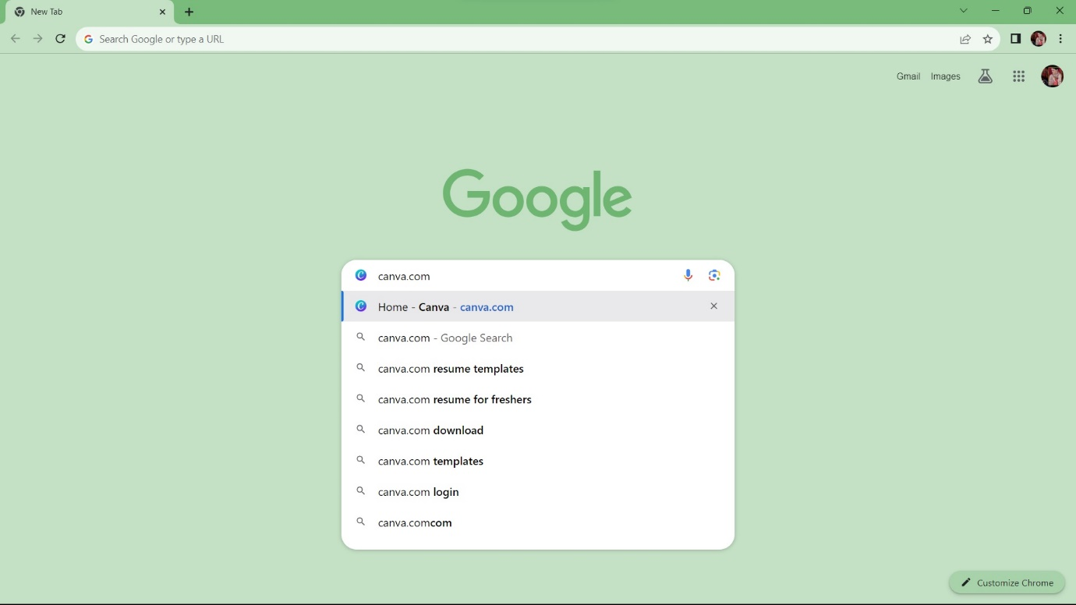

**STEP 2:** click “the canva official website”

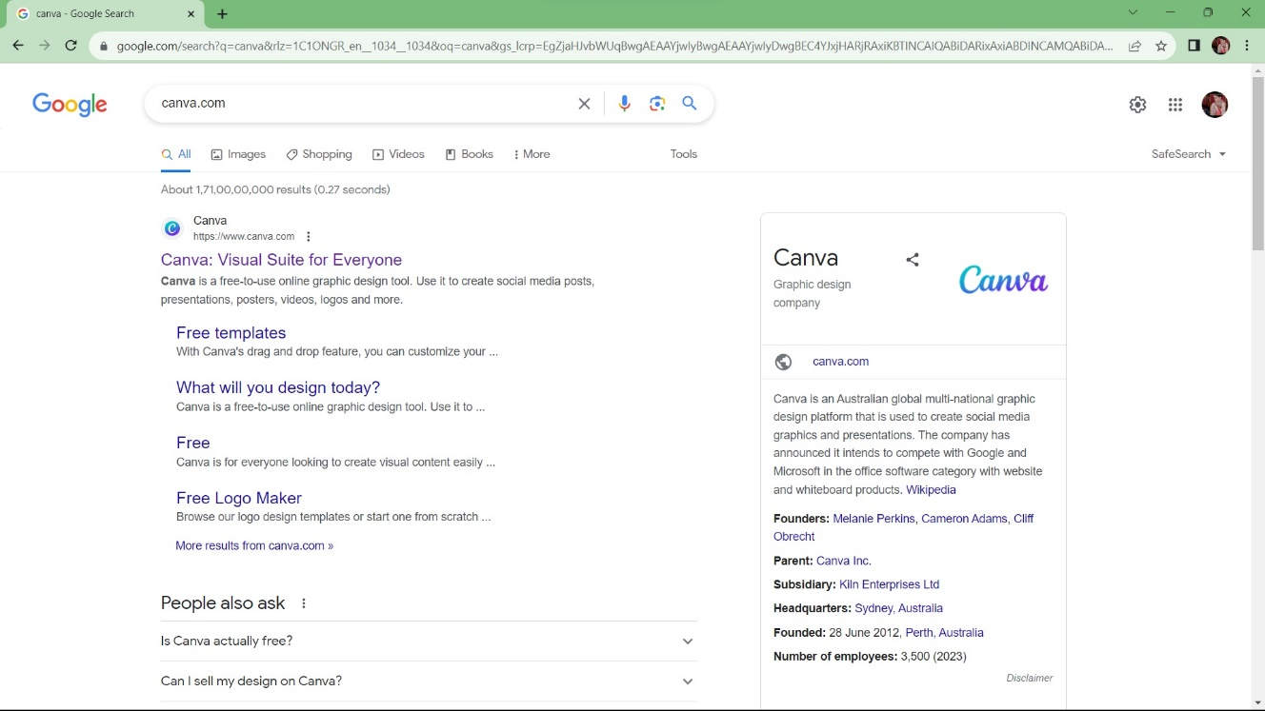

**STEP 3:** Click “create a design”

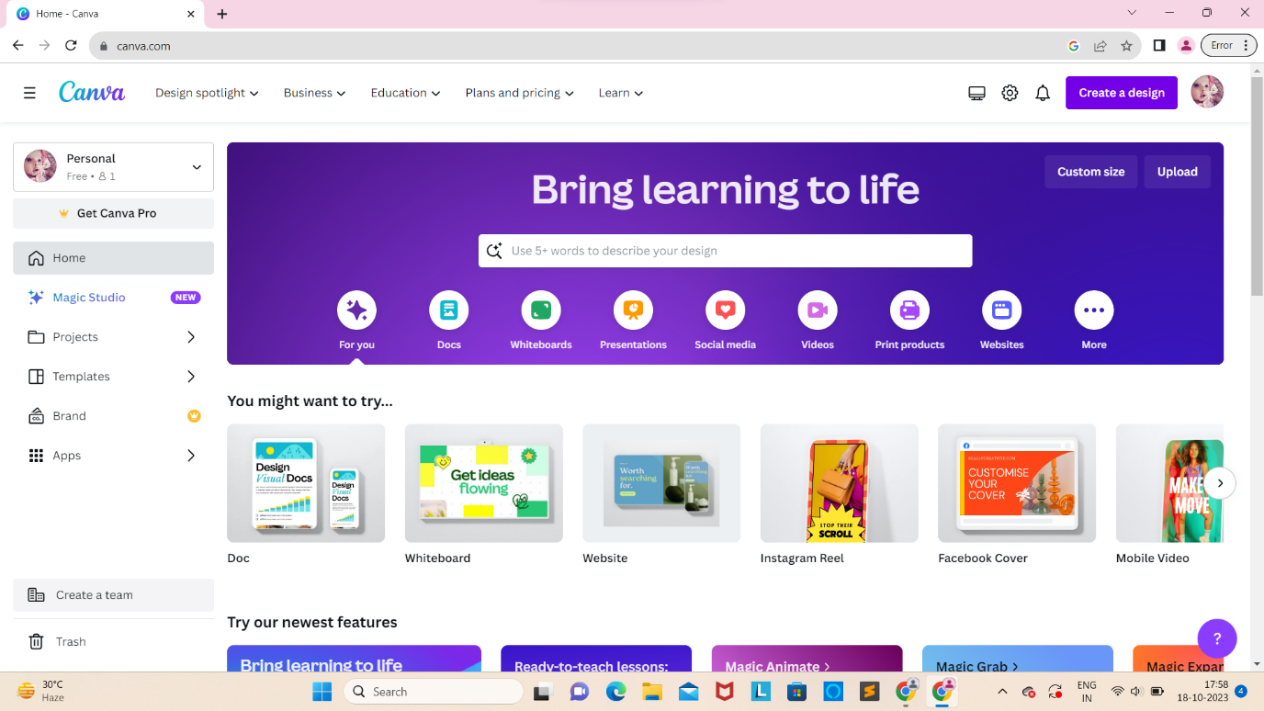

**STEP 4:**  Search “instagram post”

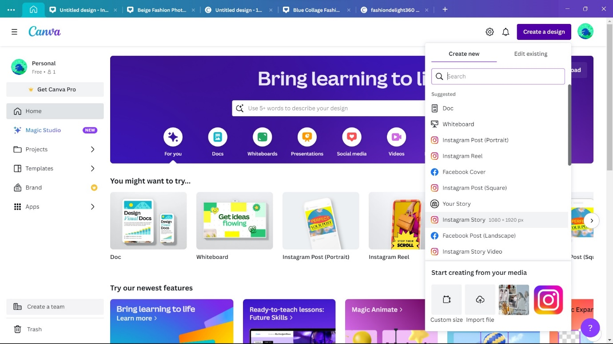

**STEP 5:** Search and click “online store”

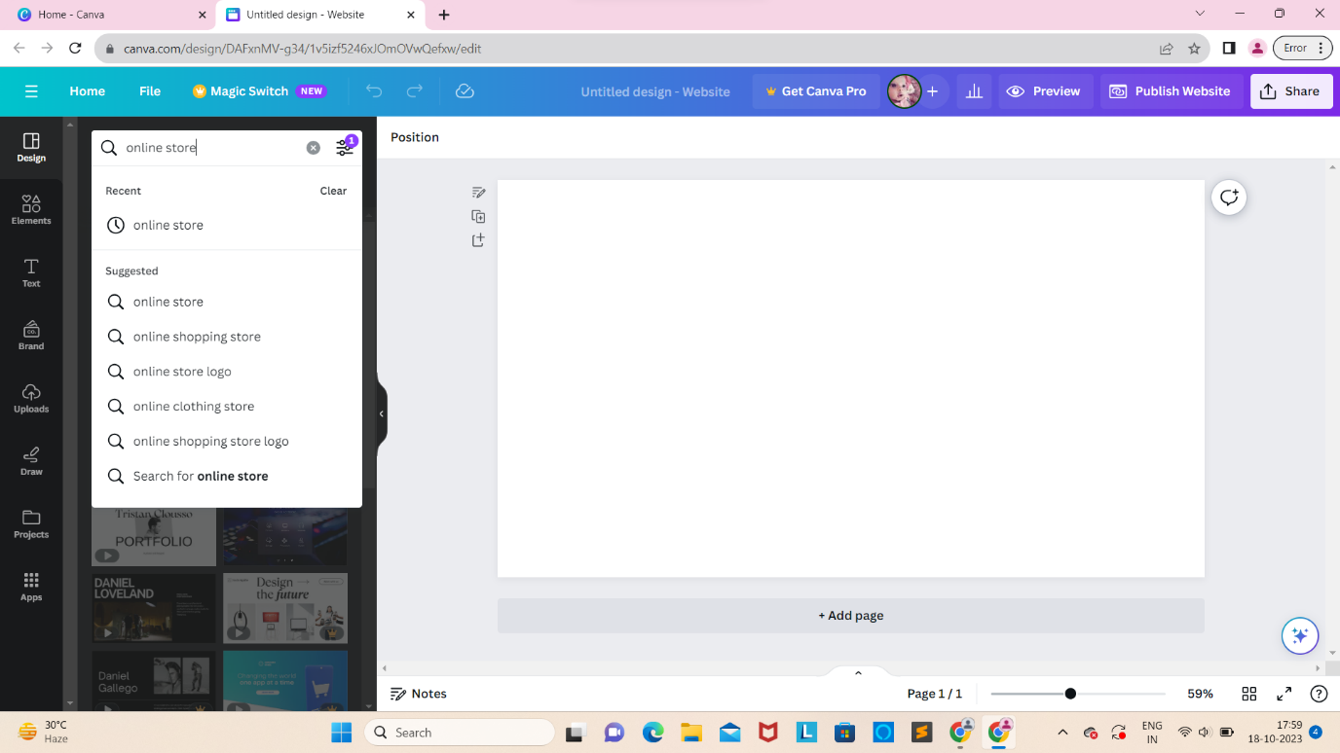

**STEP 6:** Choosing the design

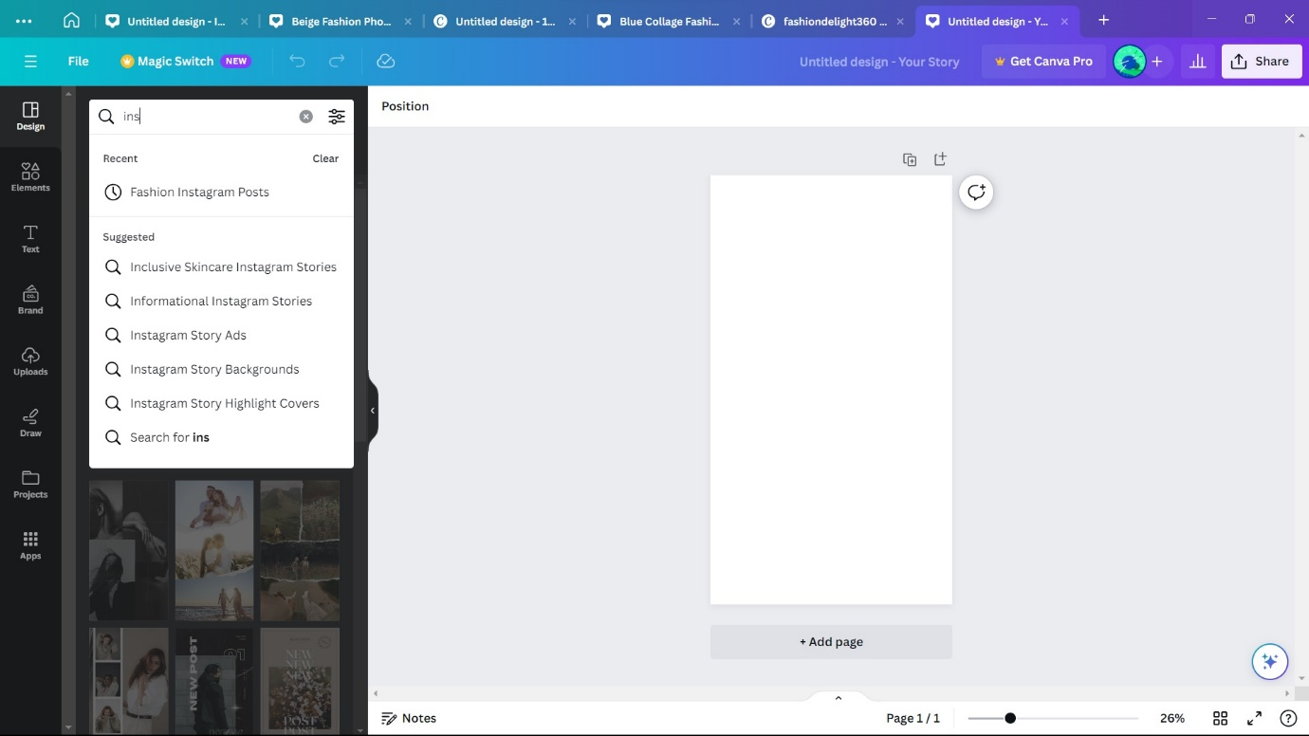

**STEP 7:** Choose template

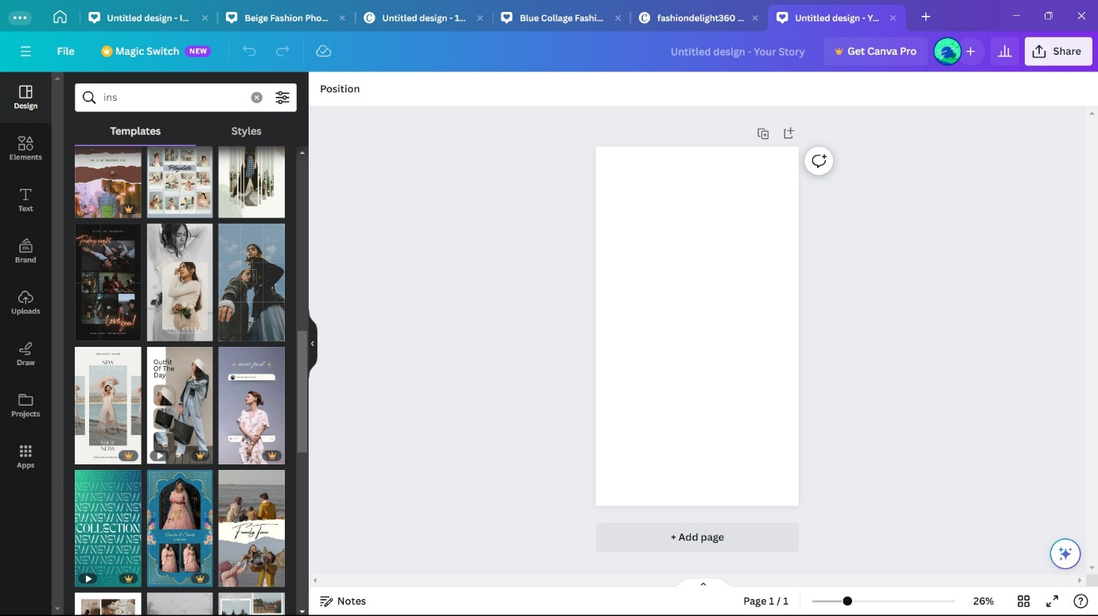

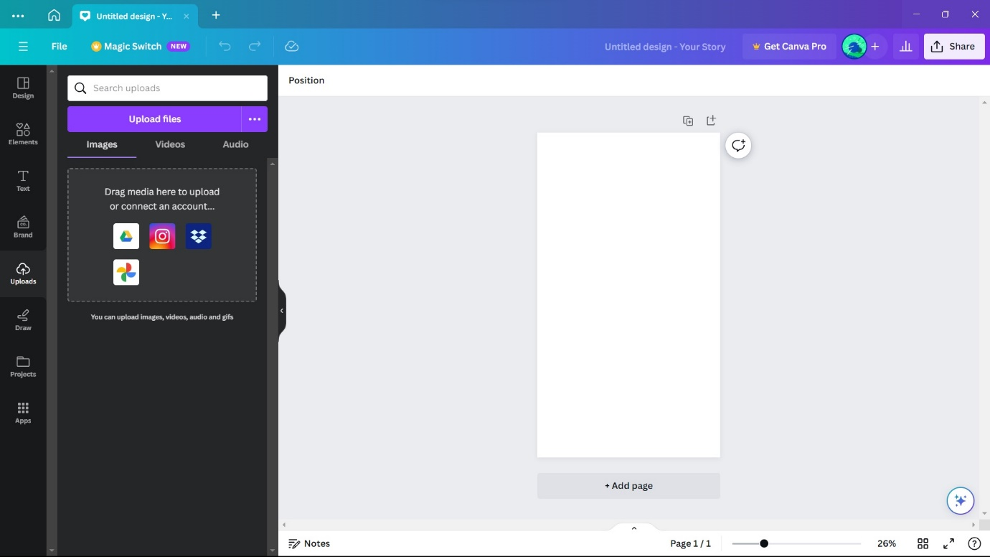

**STEP 8:** “upload logo’’

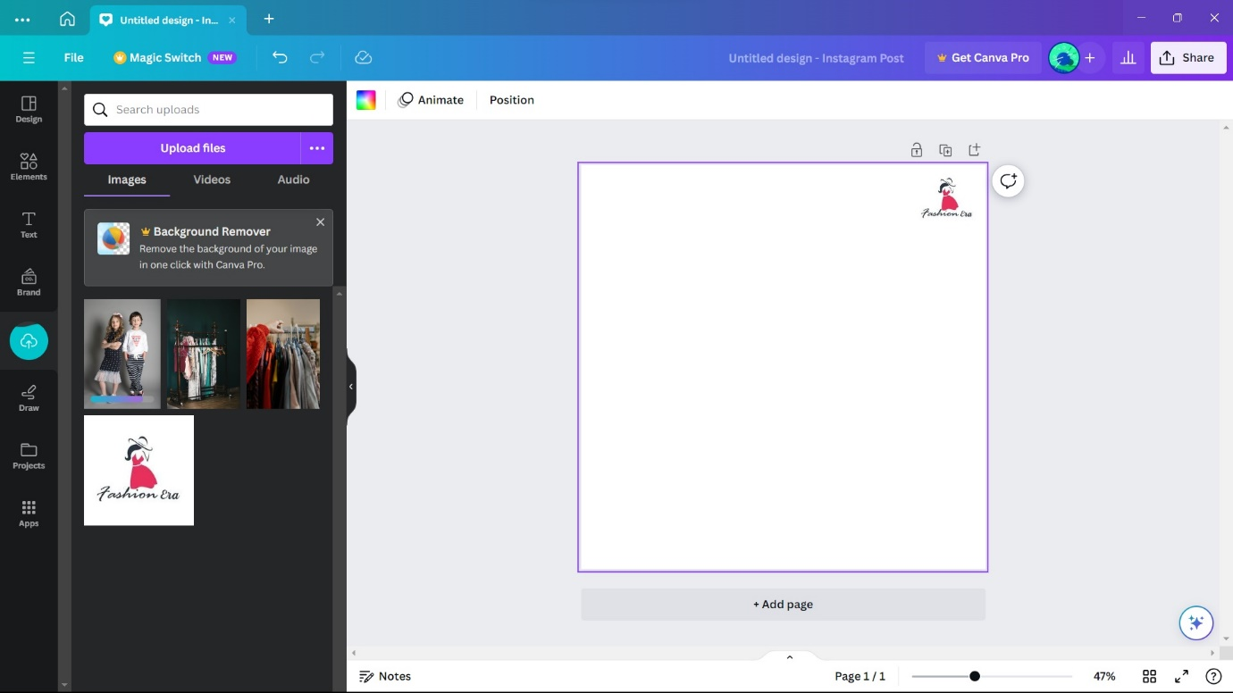

**STEP 9: “**add logo to poster”



**STEP 10: “**resize logo”

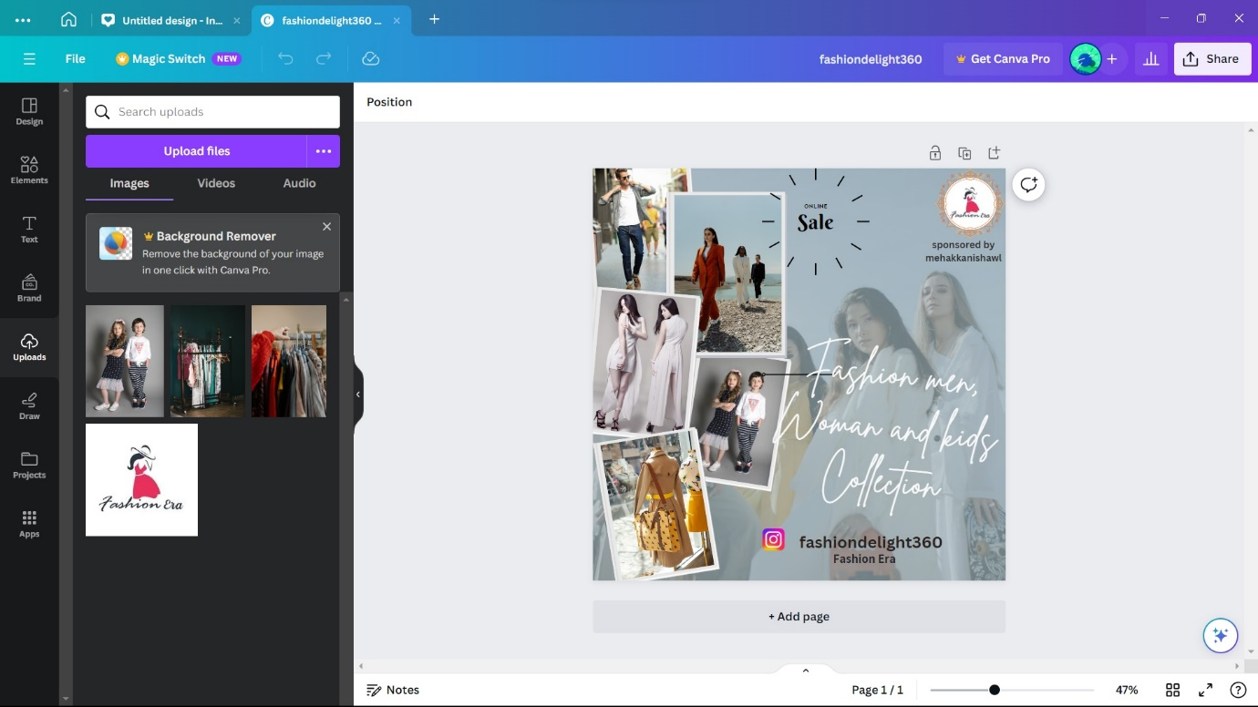

**STEP 11:** “select context”

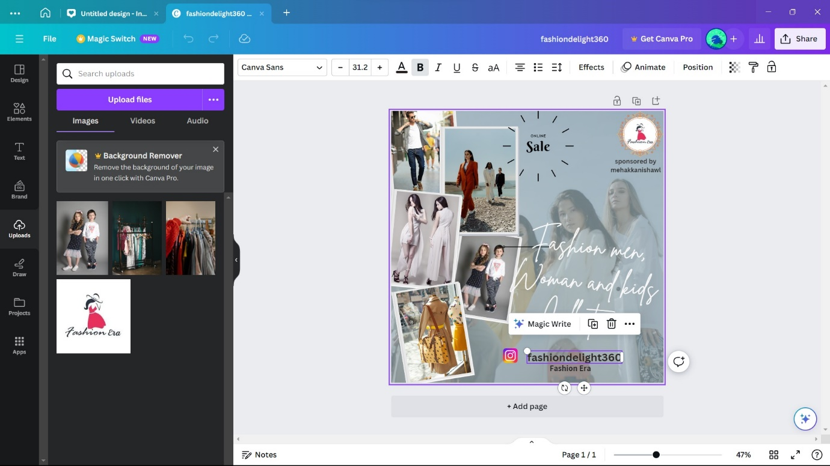

**STEP 12: “**change the text effect”

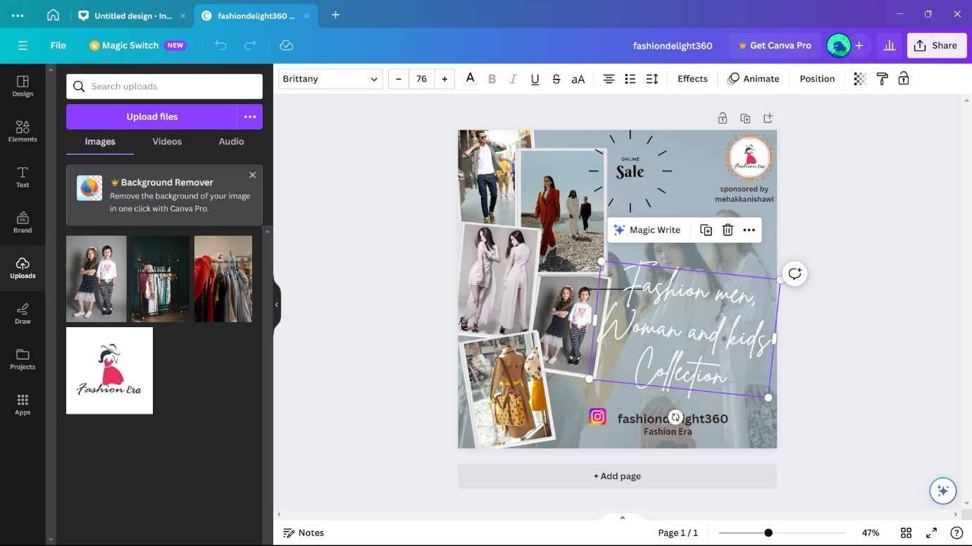

**STEP 13:** “change the test style”

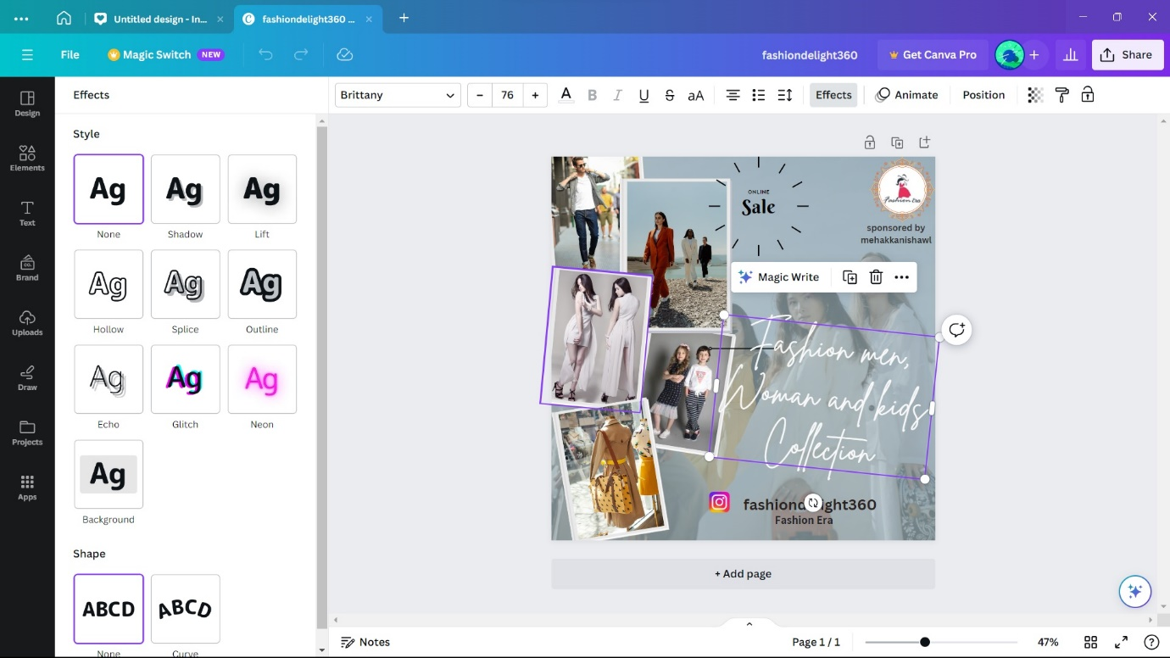

**STEP 14:** Click “elements icon

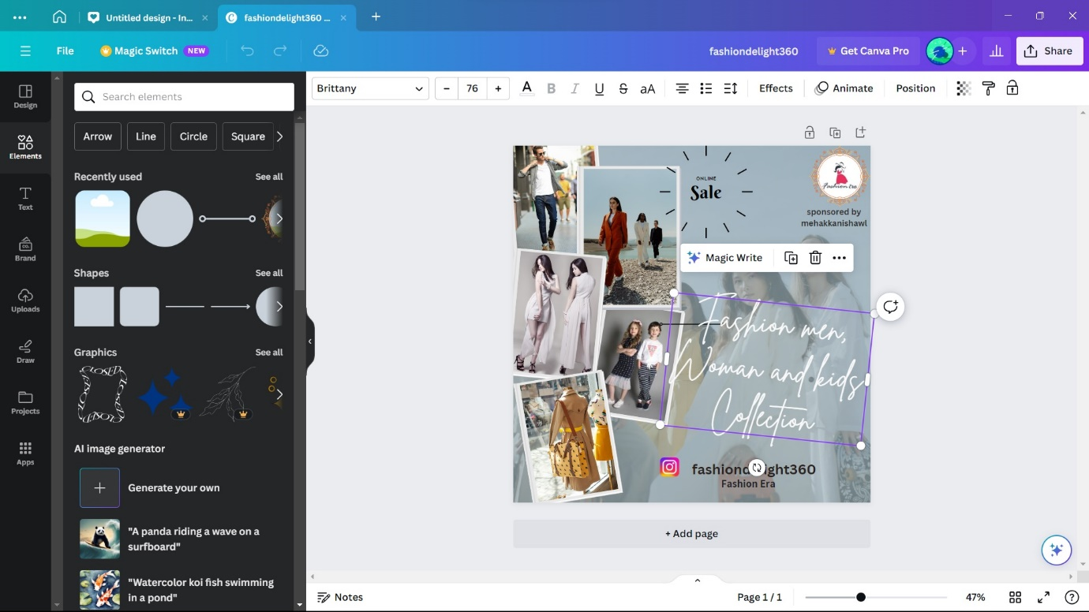



**STEP 15: “**pick a style and select it”

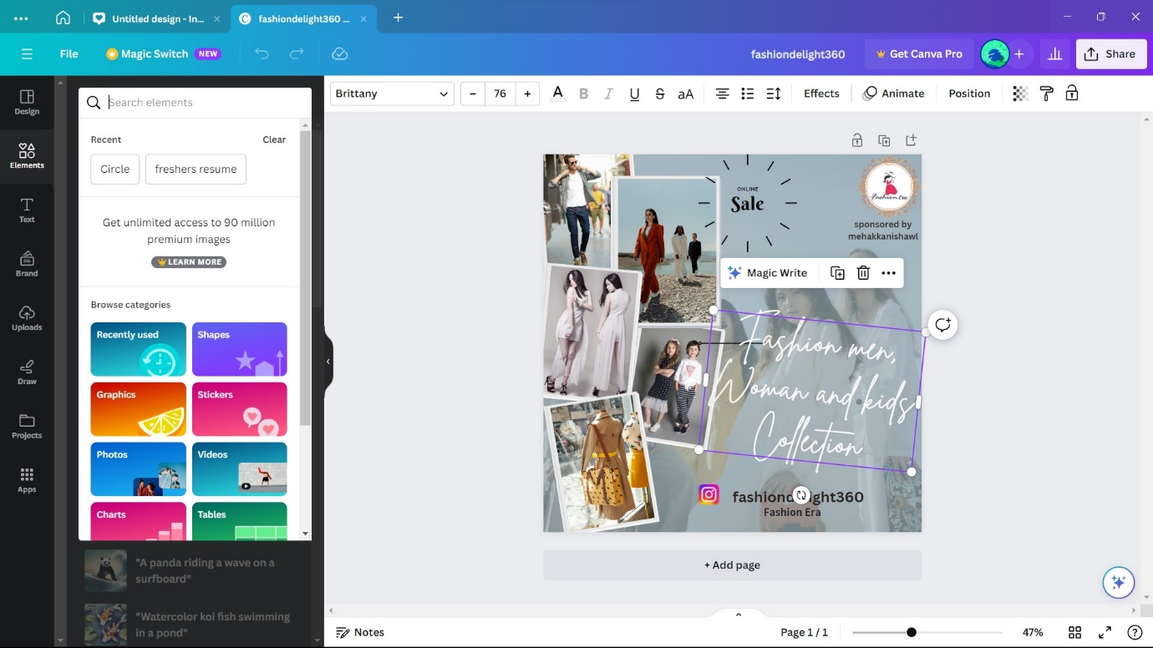

**STEP 16: “**click elements icon to add different icons images,graphics etc.”

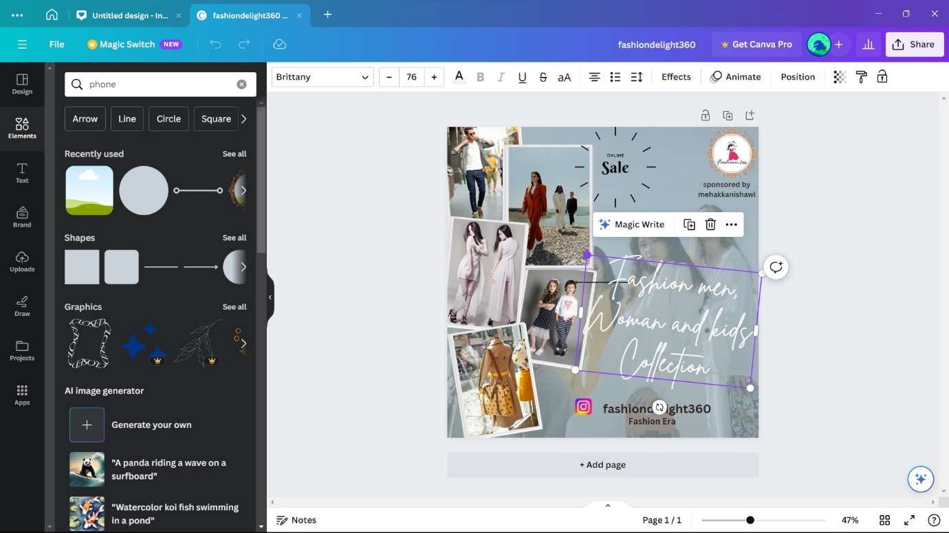

**STEP 17: “**choose font”

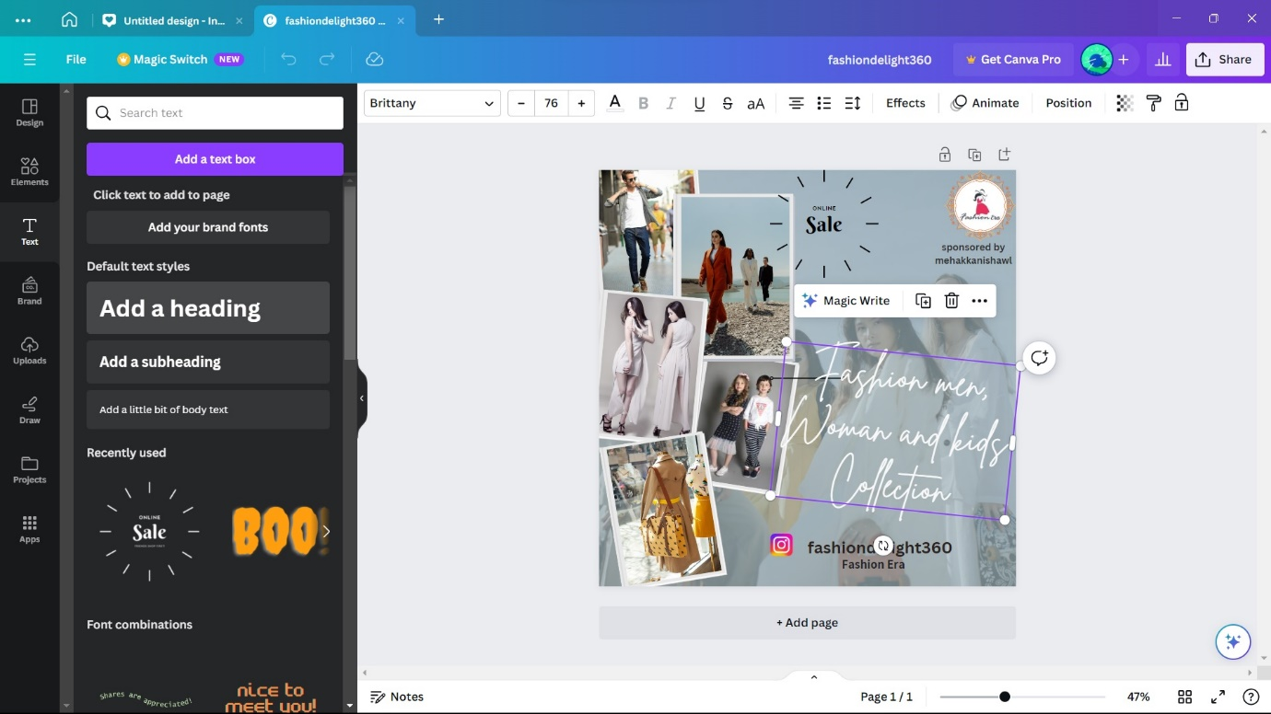

**STEP 18: “**click this icon to duplicate it”

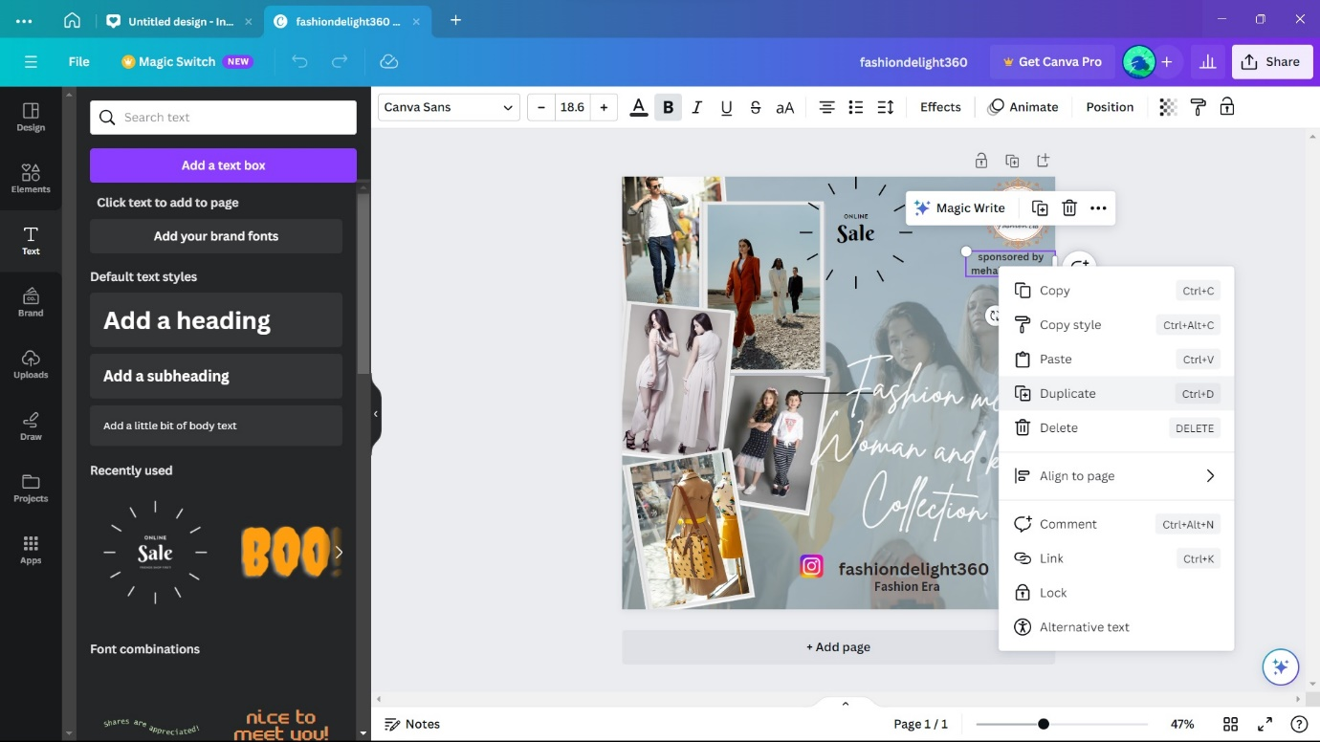

**STEP 19: “**edit the duplicate text”

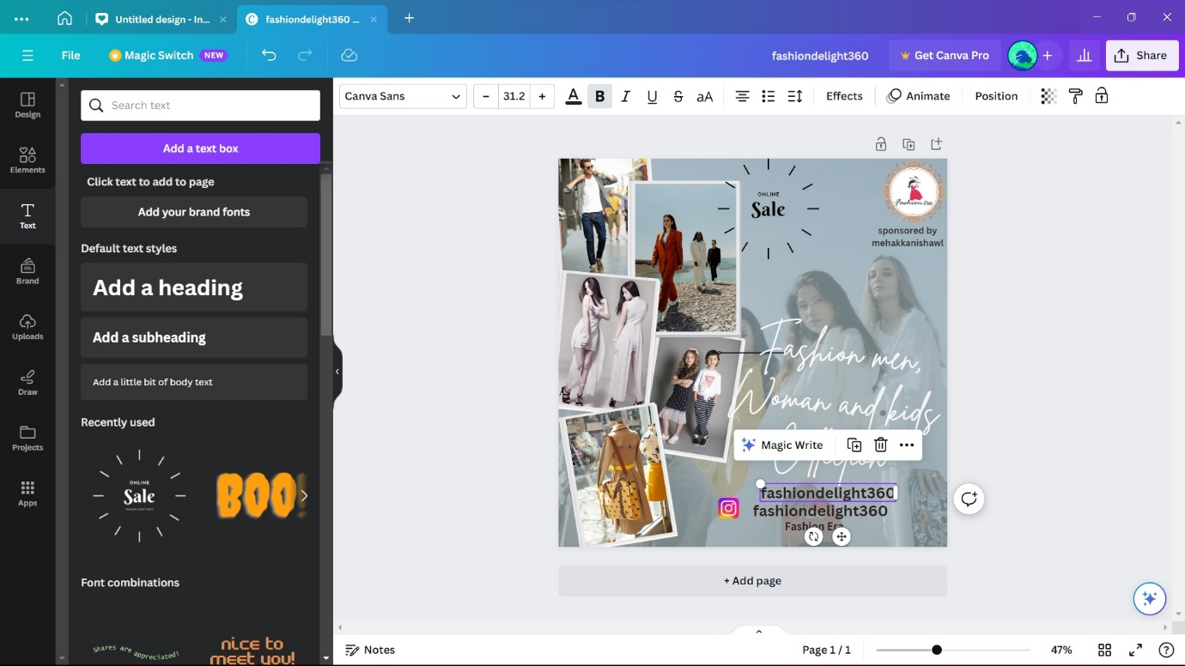

**STEP 20: “**select this to change the size of text”

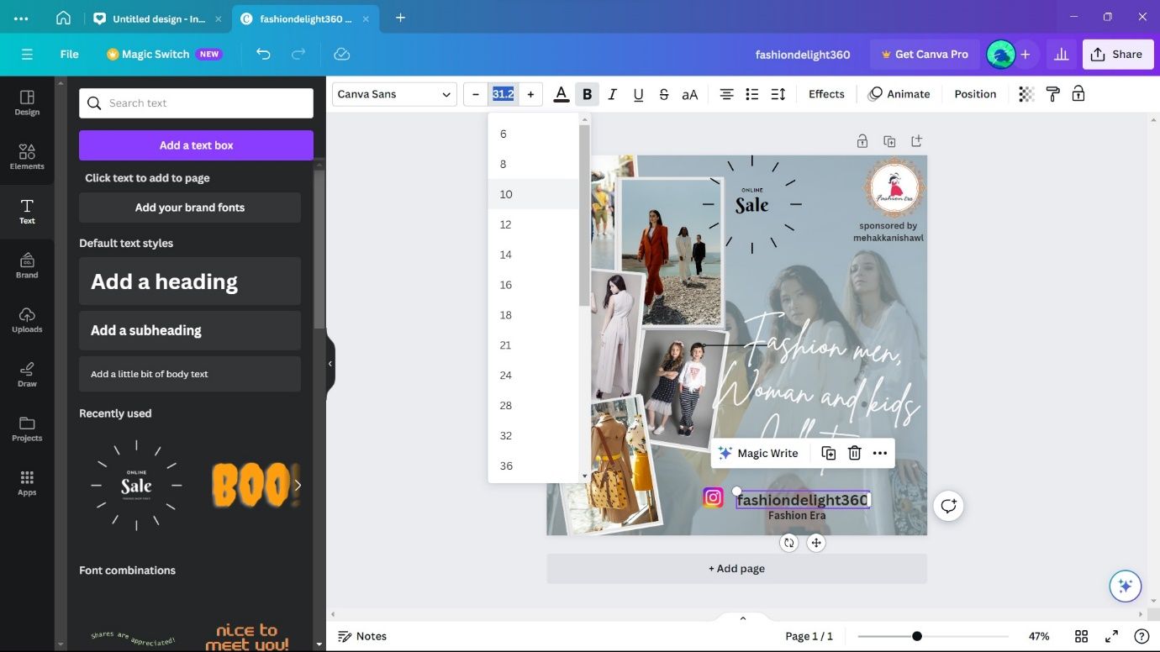

**STEP 21: “**change its upper case or lower case”

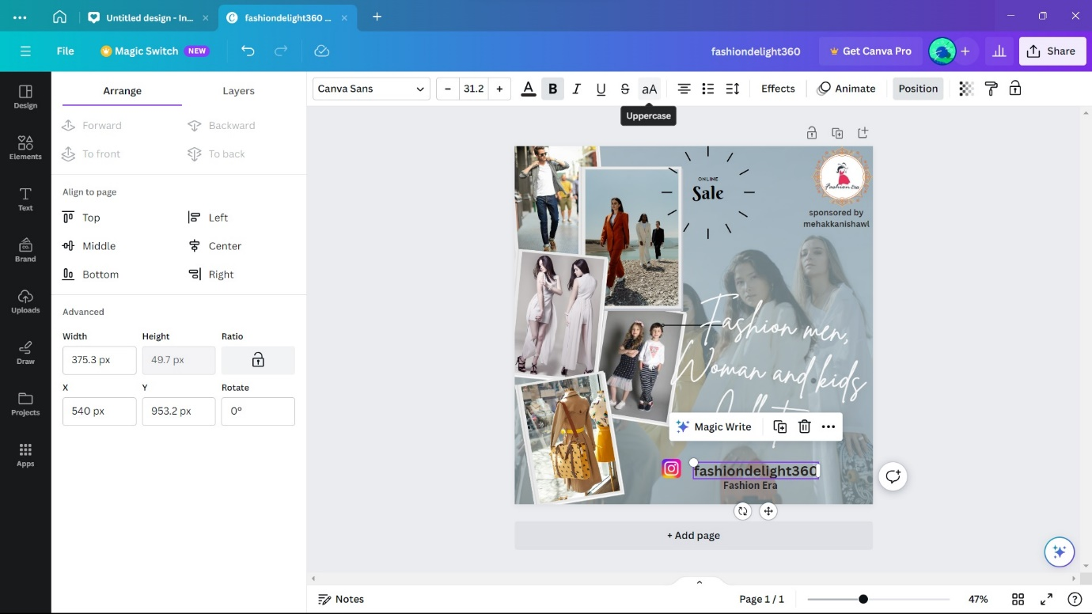

**STEP 22: “**edit the letter spacing on the design”

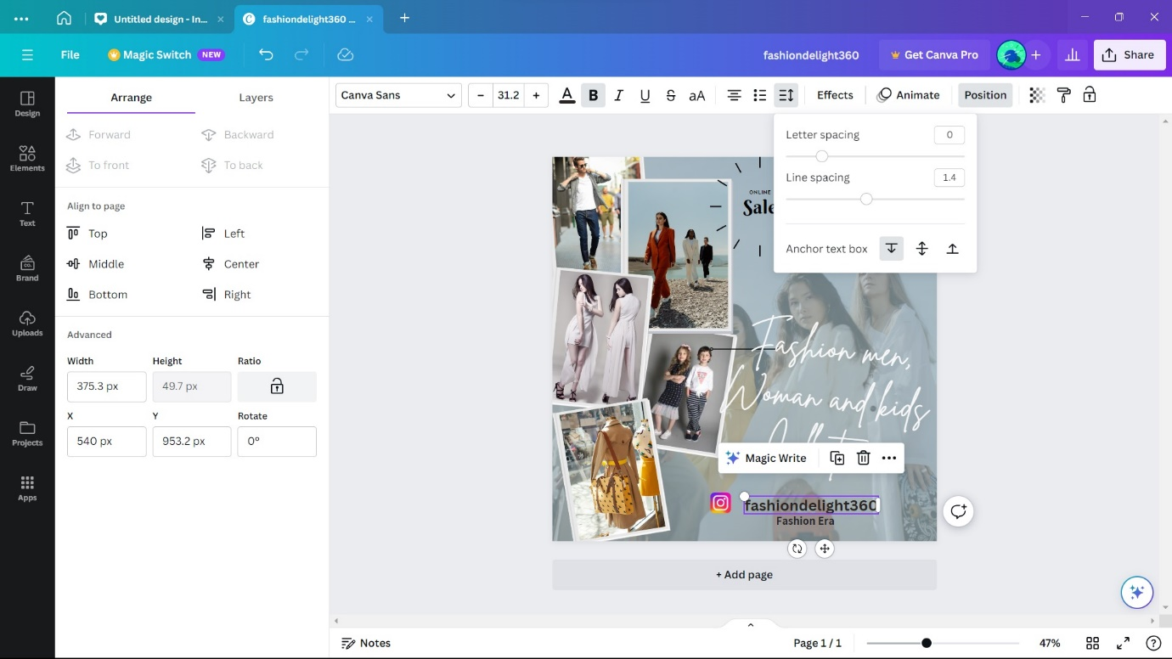

**STEP 23: “**changing the colour of the font”

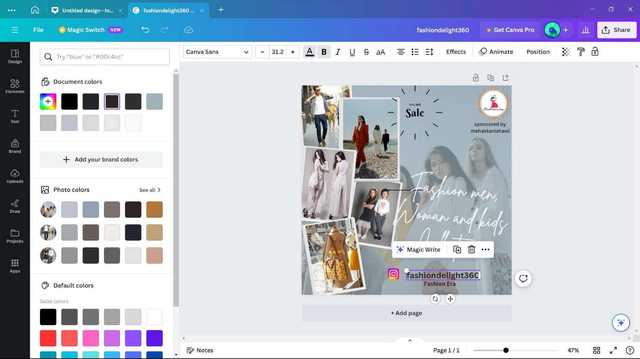

**STEP 24: “**select layer and click send backword”

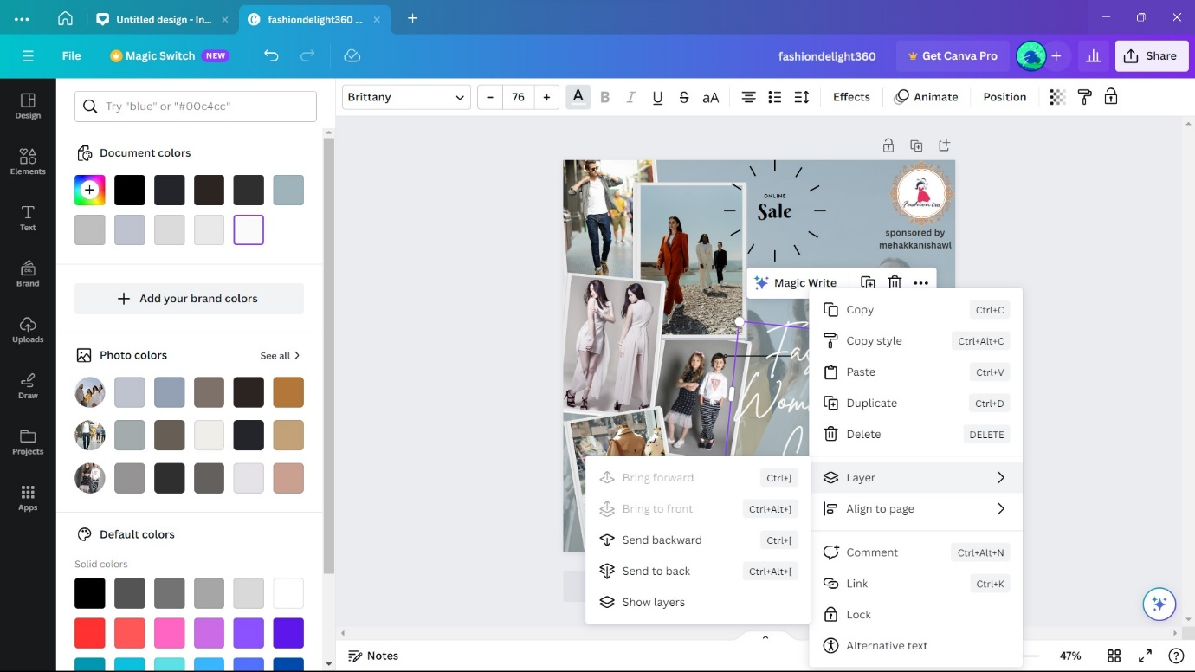

**STEP 25: “**add your comments”

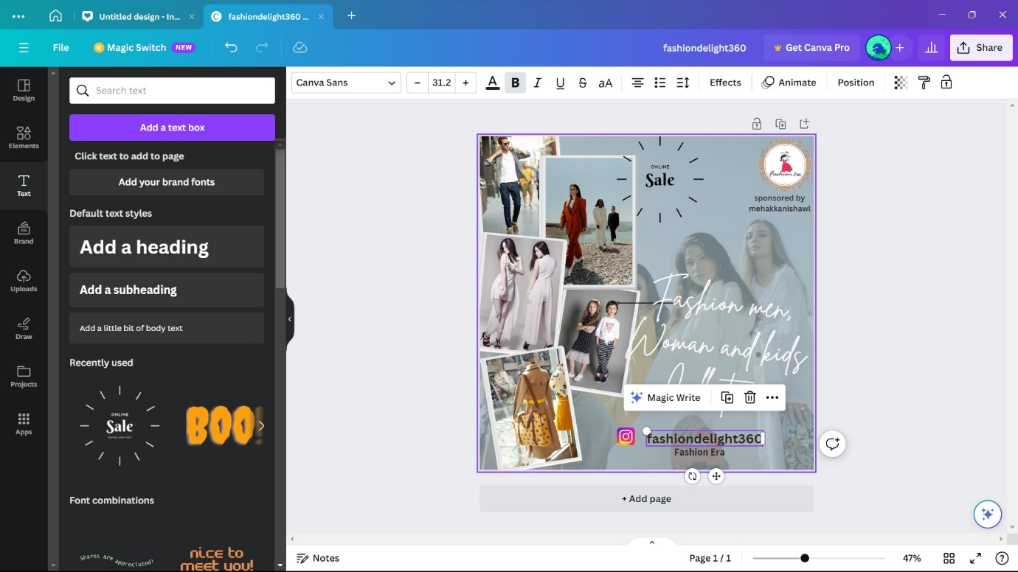

**STEP 26: “**click the share button”

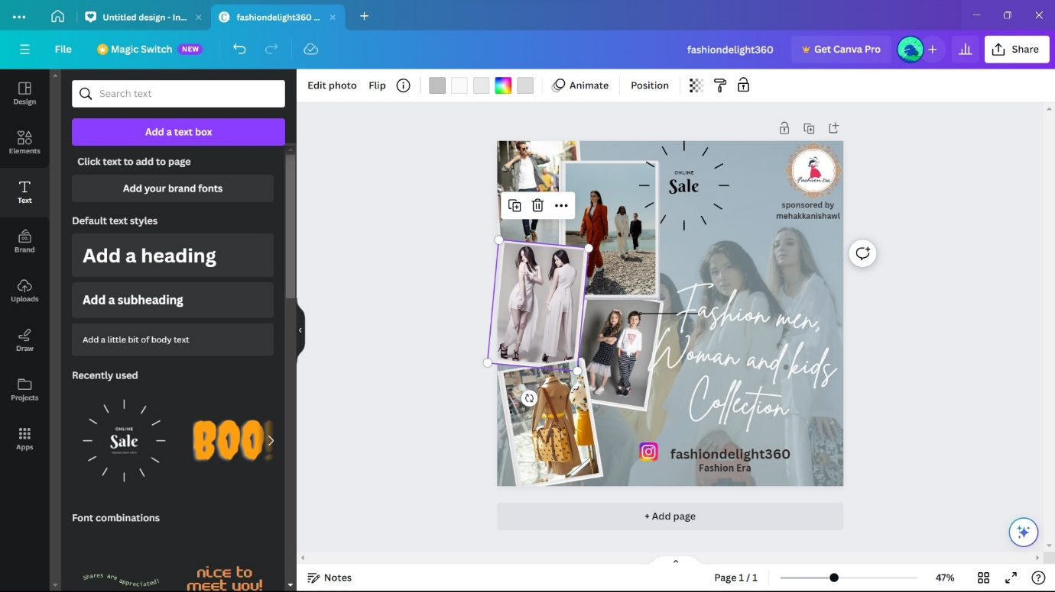

**STEP 27: “**download it in both pdf and png format”

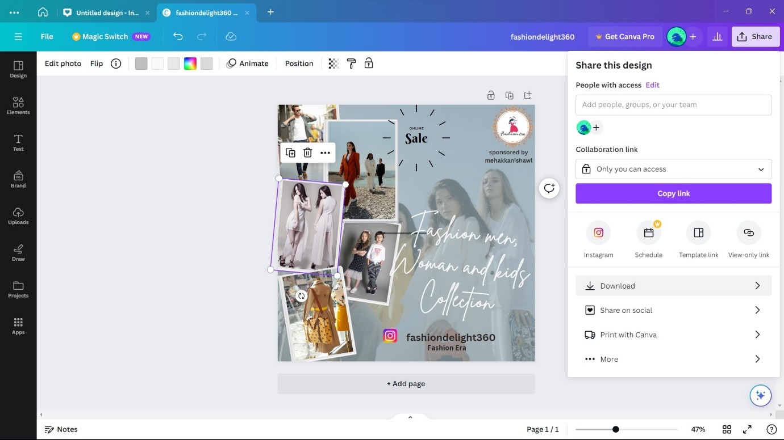

**STEP 28: “**post the picture on instagram”

**Advantages of using instagram posts for brand marketing.**

1 : Visual Appeal: Instagram is a highly visual platform, making it ideal for showcasing your brand through images and videos.

2 : Broad Audience Reach: With over a billion active users, Instagram provides access to a diverse and extensive audience.

3 : Engagement: Instagram's interactive features, like likes, comments, and shares, help foster engagement with your brand.

4 : Storytelling: Instagram allows you to tell your brand's story through captions, hashtags, and user-generated content.

5 : Hashtags: Effective use of hashtags can expand your reach and connect you with users interested in your niche.

6 : Analytics: Instagram Insights provides data on post performance, helping you refine your marketing strategy.

7 : Influencer Marketing: Collaborating with influencers can help you reach a wider audience and gain credibility.

8 : Advertisements: Instagram offers paid advertising options to target specific demographics and increase visibility.

9 : E-commerce Integration: Instagram Shopping allows users to purchase products directly from posts.

10 : Trend Awareness: Staying active on Instagram helps you stay in touch with current trends and customer preferences.

**CONCLUSION**

In conclusion, Canva's user-friendly platform has revolutionized the world of best Instagram templates by providing an accessible, versatile, and creative solution for individuals and businesses. With its extensive template library, intuitive customization options, and support for multimedia integration, Canva empowers users to craft professional posts that align with their unique branding and content goals. The platform's responsiveness ensures a seamless user experience on various devices, while its hosting capabilities simplify the process of making Instagram post accessible to a global audience. Canva has bridged the gap between design and functionality, making posts a possibility for all, regardless of their technical expertise, and offering a vibrant online presence to those who seek it.